**Experiment no 3: Loading datasets into PyTorch creating training and Testing Split**

import pprint as pp

from sklearn import datasets

import numpy as np

import torch

from torch.utils.data import Dataset, random_split

# Generate Sample Data

total_samples = 1800

X_data, Y_data = datasets.make_blobs(n_samples=total_samples, n_features=3,

centers=[(-2, 5), (3, -4)], random_state=42)

import torch

from torch.utils.data import Dataset

class CustomDataset(Dataset):

    def __init__(self, x, y):

        self.x = x

        self.y = y

    def __getitem__(self, index):

        sample = {

            'features': torch.tensor(self.x[index], dtype=torch.float32),

            'label': torch.tensor(self.y[index], dtype=torch.long)

        }

        return sample

    def __len__(self):

        return len(self.x)

# Create the Dataset Instance

dataset = CustomDataset(X_data, Y_data)

print("Total number of samples in the dataset:", len(dataset))

# Split the Dataset

train_data, val_data = random_split(dataset, [1200, 600])

print("Number of training samples:", len(train_data))

print("Number of validation samples:", len(val_data))

**OUTPUT:**





**Experiement No. 4: Creating functions to compute various losses.**

import numpy as np

def mean_squared_error(y_true, y_pred):

    return np.mean((y_true - y_pred) ** 2)

def mean_absolute_error(y_true, y_pred):

    return np.mean(np.abs(y_true - y_pred))

def binary_cross_entropy(y_true, y_pred):

    y_pred = np.clip(y_pred, 1e-9, 1 - 1e-9)

    return -np.mean(y_true * np.log(y_pred) + (1 - y_true) * np.log(1 - y_pred))

def categorical_cross_entropy(y_true, y_pred):

    y_pred = np.clip(y_pred, 1e-9, 1 - 1e-9)

    return -np.sum(y_true * np.log(y_pred)) / y_true.shape[0]

y_true = np.array([1, 0, 1, 1])

y_pred = np.array([0.9, 0.1, 0.8, 0.7])

print("Mean Squared Error:", mean_squared_error(y_true, y_pred))

print("Mean Absolute Error:", mean_absolute_error(y_true, y_pred))

print("Binary Cross-Entropy:", binary_cross_entropy(y_true, y_pred))

y_true_cat = np.array([[1, 0, 0], [0, 1, 0], [0, 0, 1]])

y_pred_cat = np.array([[0.7, 0.2, 0.1], [0.1, 0.8, 0.1], [0.2, 0.3, 0.5]])

print("Categorical Cross-Entropy:", categorical_cross_entropy(y_true_cat, y_pred_cat))

**OUTPUT:**

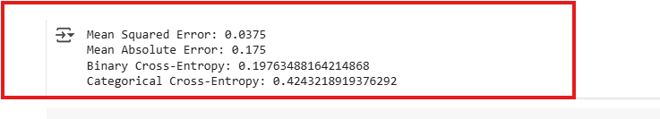

**Experiement No.5: Feeding data to pretrained neural network and making predictions**.

import tensorflow as tf

from tensorflow.keras.applications import ResNet50

from tensorflow.keras.applications.resnet50 import preprocess_input, decode_predictions

import numpy as np

import cv2

from google.colab import files

model = ResNet50(weights="imagenet")

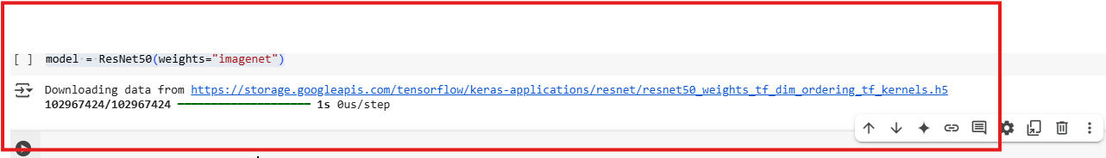

img_path = '/content/images.jpg'

img = cv2.imread(img_path)

img = cv2.cvtColor(img, cv2.COLOR_BGR2RGB)

img = cv2.resize(img, (224, 224))

img = np.expand_dims(img, axis=0)

img = preprocess_input(img)

predictions = model.predict(img)

decoded_predictions = decode_predictions(predictions, top=3)[0]

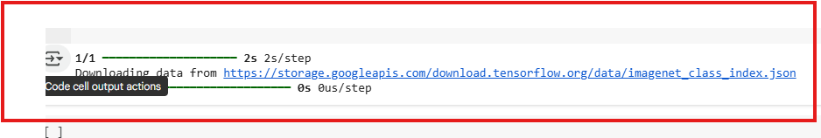

for i, (imagenet_id, label, score) in enumerate(decoded_predictions):

    print(f"{i + 1}: {label} ({score:.2f})")

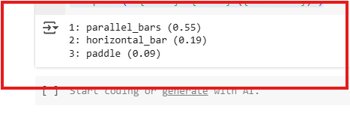

**Experiement No. 6: Implementing regression using deep neural network.**

# Step 1: Install and import everything

import numpy as np

import pandas as pd

import matplotlib.pyplot as plt

from sklearn.datasets import fetch_california_housing

from sklearn.model_selection import train_test_split

from sklearn.preprocessing import StandardScaler

from tensorflow.keras.models import Sequential

from tensorflow.keras.layers import Dense

from tensorflow.keras.optimizers import Adam

# Step 2: Load dataset

data = fetch_california_housing()

X = data.data

y = data.target

# Step 3: Preprocess data

X_train, X_test, y_train, y_test = train_test_split(X, y, test_size=0.2,

random_state=42)

scaler = StandardScaler()

X_train_scaled = scaler.fit_transform(X_train)

X_test_scaled = scaler.transform(X_test)

# Step 4: Build the model

model = Sequential([

Dense(64, activation='relu', input_shape=(X_train.shape[1],)),

Dense(64, activation='relu'),

Dense(1) # Linear output for regression

])

model.compile(optimizer=Adam(learning_rate=0.001), loss='mse', metrics=['mae'])

# Step 5: Train the model

history = model.fit(X_train_scaled, y_train, epochs=100, batch_size=32,

validation_split=0.1, verbose=1)

# Step 6: Evaluate

loss, mae = model.evaluate(X_test_scaled, y_test)

print(f"Test MAE: {mae:.3f}")

# Step 7: Plot training history

plt.plot(history.history['loss'], label='Train Loss')

plt.plot(history.history['val_loss'], label='Val Loss')

plt.xlabel("Epochs")

plt.ylabel("MSE Loss")

plt.title("Training vs Validation Loss")

plt.legend()

plt.grid(True)

plt.show()

**OUTPUT:**

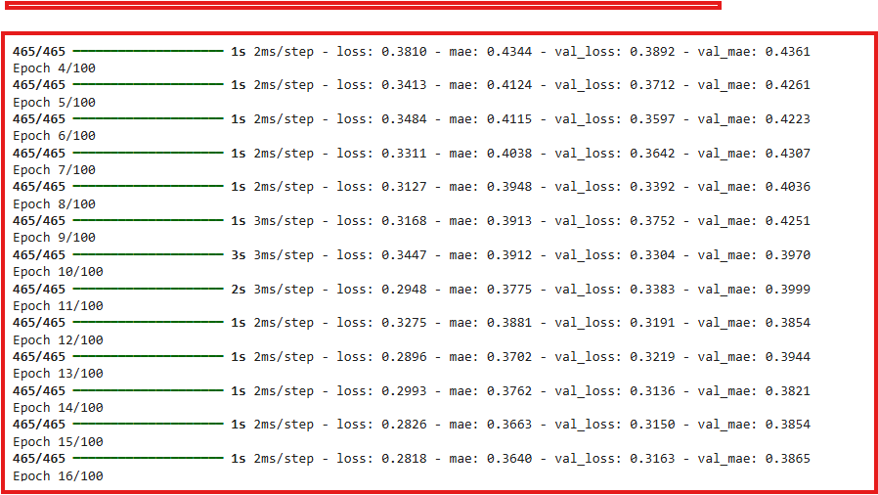

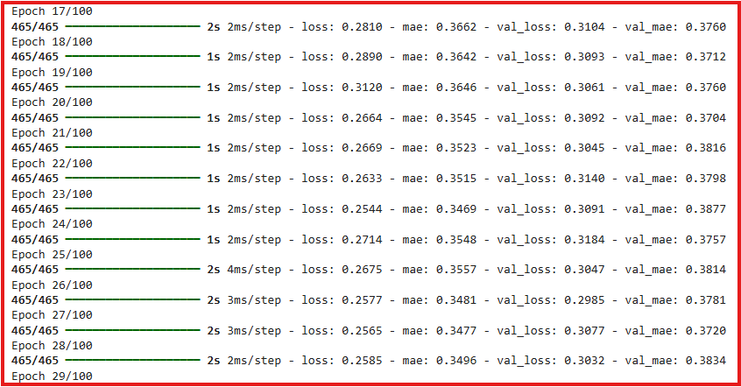

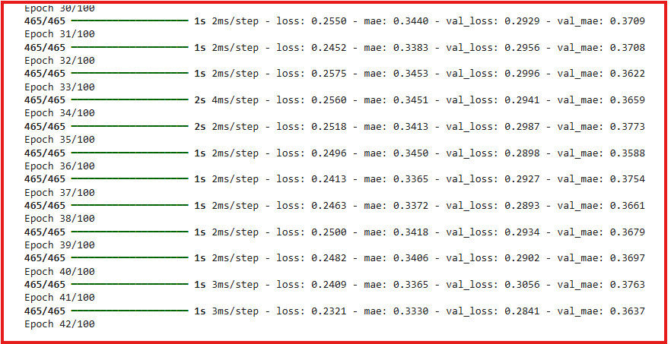

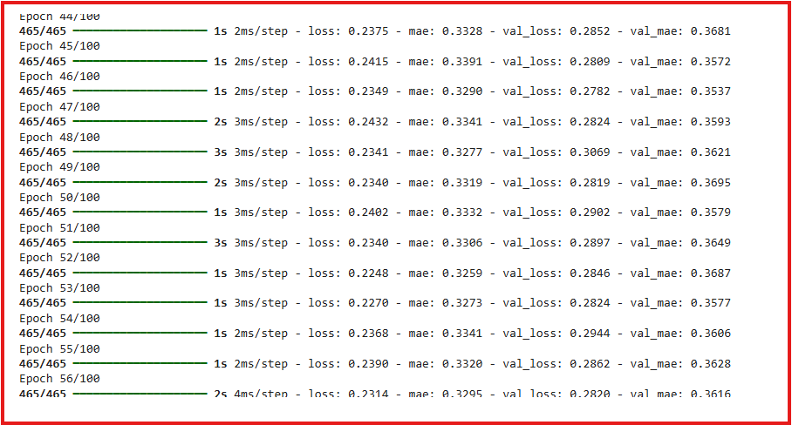

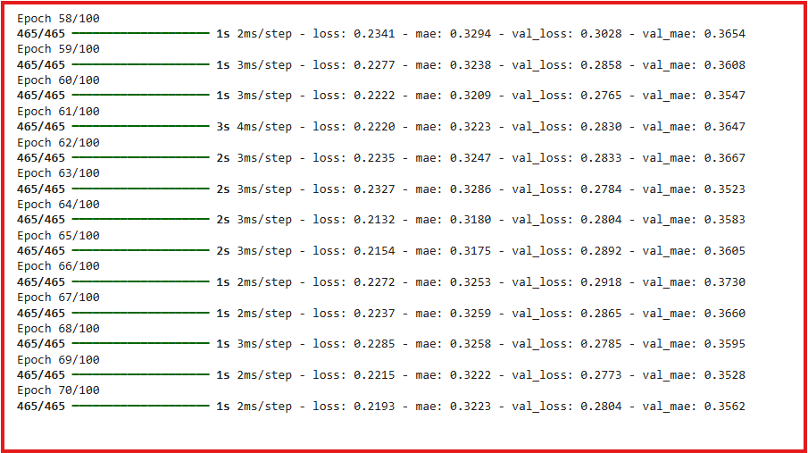

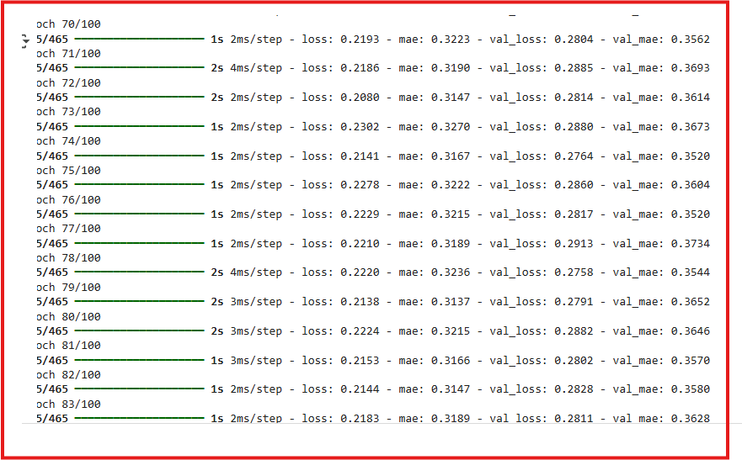

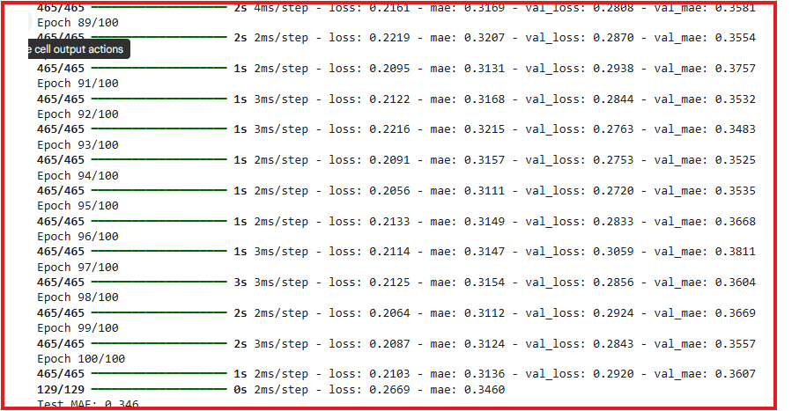

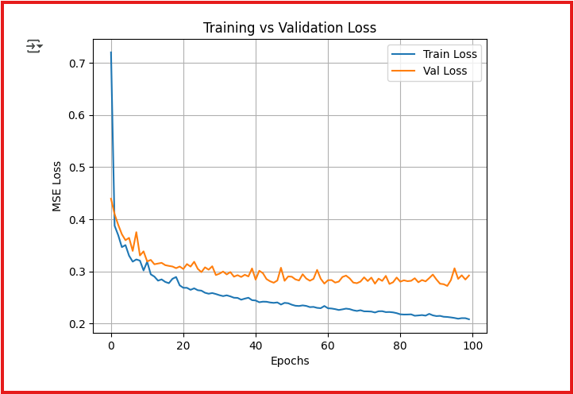

**Experiement No.7 Classifying IMDB movie review dataset using deep neural network-binary classification problem.**

import numpy as np

import matplotlib.pyplot as plt

from tensorflow import keras

from tensorflow.keras.models import Sequential

from tensorflow.keras.layers import Dense, Embedding, GlobalAveragePooling1D

from tensorflow.keras.preprocessing.sequence import pad_sequences

vocab_size = 10000

maxlen = 200

(x_train, y_train), (x_test, y_test) = keras.datasets.imdb.load_data(num_words=vocab_size)

x_train_padded = pad_sequences(x_train, maxlen=maxlen)

x_test_padded = pad_sequences(x_test, maxlen=maxlen)

model = Sequential([

    Embedding(input_dim=vocab_size, output_dim=32, input_length=maxlen),

    GlobalAveragePooling1D(),

    Dense(64, activation='relu'),

    Dense(1, activation='sigmoid')

])

model.compile(optimizer='adam', loss='binary_crossentropy', metrics=['accuracy'])

history = model.fit(x_train_padded, y_train, epochs=10, batch_size=512, validation_split=0.2, verbose=1)

loss, accuracy = model.evaluate(x_test_padded, y_test)

print(f"Test Accuracy: {accuracy:.3f}")

plt.plot(history.history['accuracy'], label='Train Accuracy')

plt.plot(history.history['val_accuracy'], label='Val Accuracy')

plt.xlabel("Epochs")

plt.ylabel("Accuracy")

plt.title("Training vs Validation Accuracy")

plt.legend()

plt.grid(True)

plt.show()

**OUTPUT:**

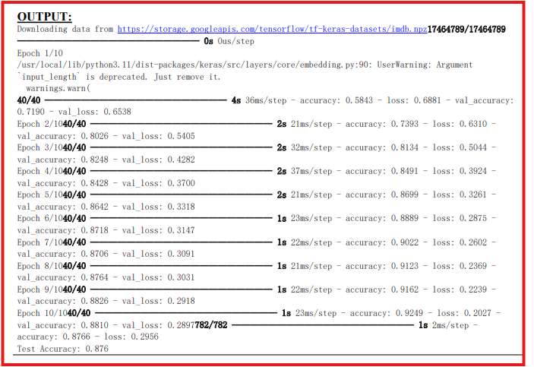

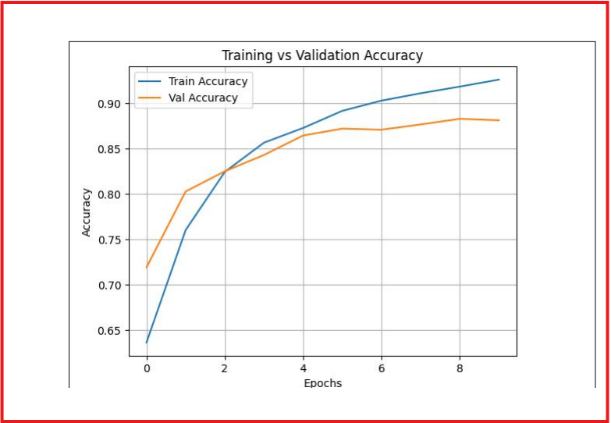

**Experiement No 8. Classifying Reuters dataset using deep neural network-multiclassclassification problem**

import numpy as np

import matplotlib.pyplot as plt

from tensorflow import keras

from tensorflow.keras.models import Sequential

from tensorflow.keras.layers import Dense, Dropout

from tensorflow.keras.utils import to_categorical

from tensorflow.keras.datasets import reuters

# Step 2: Load the Reuters dataset

num_words = 10000 # Use top 10,000 words

(x_train, y_train), (x_test, y_test) = reuters.load_data(num_words=num_words)# Step 3: Vectorize the input data (convert sequences to one-hot encoded vectors)def vectorize_sequences(sequences, dimension=10000):

results = np.zeros((len(sequences), dimension))

for i, sequence in enumerate(sequences):

results[i, sequence] = 1.0

return results

x_train_vec = vectorize_sequences(x_train)

x_test_vec = vectorize_sequences(x_test)

# Step 4: One-hot encode the labels

y_train_cat = to_categorical(y_train)

y_test_cat = to_categorical(y_test)

# Step 5: Build the model

model = Sequential([

Dense(128, activation='relu', input_shape=(10000,)),

Dropout(0.5),

Dense(64, activation='relu'),

Dense(46, activation='softmax') # 46 output classes for Reuters dataset])

# Step 6: Compile the model

model.compile(optimizer='adam', loss='categorical_crossentropy',

metrics=['accuracy'])

# Step 7: Train the model

history = model.fit(

x_train_vec, y_train_cat,

epochs=10,

batch_size=512,

validation_split=0.2,

verbose=1

)

# Step 8: Evaluate on the test set

loss, accuracy = model.evaluate(x_test_vec, y_test_cat)

print(f"Test Accuracy: {accuracy:.3f}")

# Step 9: Plot training history

plt.plot(history.history['accuracy'], label='Train Accuracy')

plt.plot(history.history['val_accuracy'], label='Validation Accuracy')

plt.title("Training vs Validation Accuracy")

plt.xlabel("Epochs")

plt.ylabel("Accuracy")

plt.legend()

plt.grid(True)

plt.show()

**OUTPUT:**

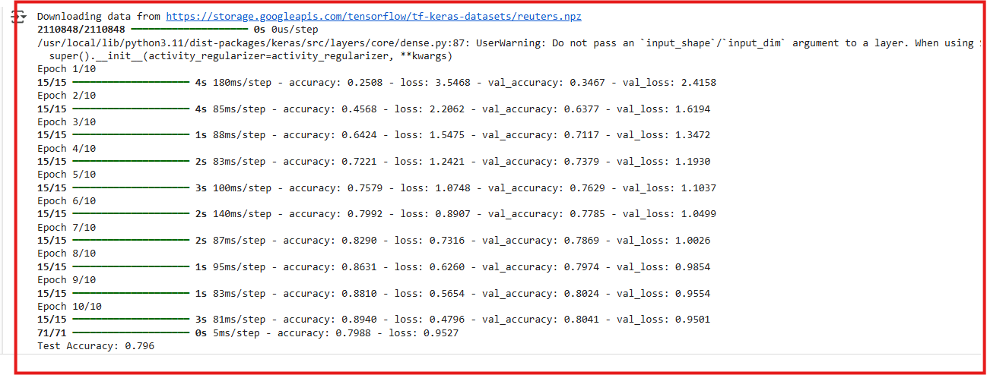

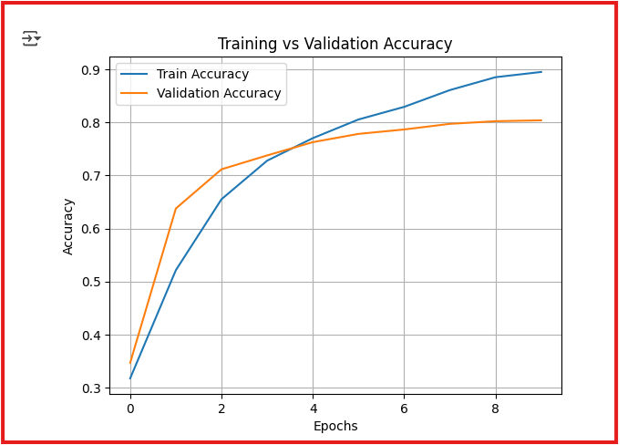

**Experiement No 9.Classifying MNIST Dataset using CNN.**

import tensorflow as tf

from tensorflow.keras import layers, models

import matplotlib.pyplot as plt

(x_train, y_train), (x_test, y_test) = tf.keras.datasets.mnist.load_data()

x_train = x_train.reshape((x_train.shape[0], 28, 28, 1)).astype('float32') / 255

x_test = x_test.reshape((x_test.shape[0], 28, 28, 1)).astype('float32') / 255

y_train = tf.keras.utils.to_categorical(y_train, 10)

y_test = tf.keras.utils.to_categorical(y_test, 10)

model = models.Sequential([

    layers.Conv2D(32, (3, 3), activation='relu', input_shape=(28, 28, 1)),

    layers.MaxPooling2D((2, 2)),

    layers.Conv2D(64, (3, 3), activation='relu'),

    layers.MaxPooling2D((2, 2)),

    layers.Conv2D(64, (3, 3), activation='relu'),

    layers.Flatten(),

    layers.Dense(64, activation='relu'),

    layers.Dense(10, activation='softmax')

])

model.compile(optimizer='adam', loss='categorical_crossentropy', metrics=['accuracy'])

history = model.fit(x_train, y_train, epochs=5, batch_size=64, validation_split=0.2, verbose=1)

test_loss, test_acc = model.evaluate(x_test, y_test)

print(f"Test accuracy: {test_acc:.4f}")

plt.plot(history.history['accuracy'], label='Train Accuracy')

plt.plot(history.history['val_accuracy'], label='Validation Accuracy')

plt.title('Training and Validation Accuracy')

plt.xlabel('Epochs')

plt.ylabel('Accuracy')

plt.legend()

plt.grid(True)

plt.show()

**OUTPUT:**

